
Deland N. Ngong
USIU-Africa : MID-TERM PROJECT(APT3065)
Concept Note

Contents
1. Project Title 2
2. Introduction & Background 2
3. Problem Statement 2
4. Literature review 3
5. Proposed Solution 3
6. Project Scope and System Boundaries 4
In-Scope (Core MVP Deliverables) 4
Out-of-Scope (Deferred for Future Iterations) 4
7. System Requirements 4
Functional Requirements 4
Non-Functional Requirements 5
8. Feasibility Analysis 5
9. Project Objectives 5
General Objective 5
Specific Objectives 6
10. Significance & Expected Impact 6
11. Gantt Chart 7
References 8

1. Project Title
Development of an Automated Academic Advising Appointment and Case Management System (AAACMS)

2. Introduction & Background
Academic advising is a cornerstone of higher education, directly impacting student retention, academic progression, and graduation clearance. In many modern universities, advising serves as the primary bridge between students navigating complex curricula and faculty members providing mentorship. Historically, this process has relied heavily on manual coordination, unstructured email correspondence, and physical walk-ins. As student populations grow, maintaining this traditional approach strains administrative resources and diminishes the efficiency of academic guidance.

3. Problem Statement
The current manual and semi-automated methods of handling academic advising on campus have resulted in severe operational bottlenecks characterized by:
- Communication Gaps: High volumes of unstructured student emails lead to delayed or entirely unreplied requests, leaving critical student issues unresolved.
- Uncoordinated Scheduling: The lack of a centralized scheduling mechanism causes physical crowding, resulting in long queues outside advisors' offices, particularly during peak hours or short breaks between classes.
- Time Inefficiency: Students frequently waste valuable time waiting in lines – occasionally going late or missing classes entirely - only to sometimes leave unattended due to constraints on the advisor's availability.
- Information Asymmetry & Lack of Continuity: Advisors lack an immediate, organized repository of a student’s historical advising record. Consequently, repetitive problems must be re-evaluated from scratch during every visit, preventing data-driven insights into recurring departmental bottlenecks.

4. Literature review
The operational bottlenecks identified in manual campus academic advising are widely documented in contemporary higher education research. Modern educational technology frameworks emphasize that replacing unstructured processes with centralized digital solutions is vital for eliminating physical queueing friction (James et al., 2024). Uncoordinated, email-heavy workflows often cause students to experience a severe administrative communication gap, which directly leads to lower institutional engagement and heightened frustration during critical academic checkpoints (James et al., 2024).
To mitigate these issues, implementing structured digital platforms allows universities to systematically optimize resources and coordinate workflows effectively. Research by Amiri (2026) demonstrates that deploying information systems that capture ongoing historical data allows departments to maintain a transparent, continuity-driven record of student support. Furthermore, when developing automated dashboards to handle student workflows, integrating strict role management and secure information data handling is essential for maintaining systemic integrity across campus networks (Peddi, 2024). By combining dynamic scheduling engines with persistent database logs, institutions can successfully reduce administrative burdens, eliminate waiting queues, and deliver structured, proactive academic counseling (Amiri, 2026; Peddi, 2024).

5. Proposed Solution
To resolve these inefficiencies, this project proposes the development of the Academic Advising Appointment and Case Management System (AAACMS). This system is a web-based management information platform designed to streamline and automate the scheduling workflow while establishing a historical repository for advising interactions.
The system will feature three core modules:
- Student Module: Allows students to view real-time availability slots filtered by department, advisor, and specific issue categories (e.g., registration guidance, prerequisite waivers). Students can book a slot and select an appointment mode (In-Person or Online via external communication links).
- Advisor Module: Provides faculty members with a dedicated dashboard to set weekly office hours, view upcoming appointment queues with attached student details prior to the session, and securely log post-session notes and decisions.
- Case Log/History Subsystem: Automatically archives past interaction details, providing an immutable reference trail for future appointments to ensure continuity of care and support.

6. Project Scope and System Boundaries
To ensure successful deployment within a single-semester timeframe, the scope of the AAACMS is clearly bounded into inclusions (In-Scope) and exclusions (Out-of-Scope).

In-Scope (Core MVP Deliverables)
- Role-Based Dashboards
- Dynamic Slot Management
- Appointment Management Engine
- Persistent Case Logging

Out-of-Scope (Deferred for Future Iterations)
- Live Video Conferencing Integration
- Automated Email/SMS Gateway Servers
- Biometric or Institutional Single Sign-On (SSO) Integration

7. System Requirements

Functional Requirements
FR-1: User Authentication & Role Management
FR-2: Dynamic Availability Management
FR-3: Appointment Booking Engine
FR-4: Case History Logging:
FR-5: Historical Record Retrieval

Non-Functional Requirements
NFR-1: Security & Data Privacy
NFR-2: Usability & Responsiveness
NFR-3: Performance/Response Time

8. Feasibility Analysis
This project is highly feasible across technical, operational, and schedule dimensions despite a constrained timeframe. Technically, the system utilizes proven, accessible web development technologies (such as Python/Django paired with a PostgreSQL relational database) which offer robust, built-in user authentication modules and automated admin panels. This drastically simplifies development, eliminating the need to write backend infrastructure from scratch. Operationally, the system addresses an existing campus pain point without disrupting established institutional academic policies; it simply digitizes the current workflow. Given the limited multi-week timeline and concurrent course loads, scheduling feasibility is achieved by strictly scoping the system to a Minimum Viable Product (MVP) - focusing purely on core booking and historical text logging while deferring complex third-party API integrations (such as direct video call hosting) to future system iterations.

9. Project Objectives

General Objective
To design, model, and document a secure, centralized Academic Advising Appointment and Case Management System that optimizes resource allocation and eliminates scheduling friction on campus.

Specific Objectives
- To design an intuitive database schema capable of managing user identities, flexible availability slots, and persistent case histories.
- To implement a prototype that minimizes student wait times and automates schedule updates for faculty advisors.
- To evaluate the system’s feasibility and provide comprehensive documentation suitable for institutional deployment or commercial positioning.

10. Significance & Expected Impact
- For Students: Eliminates unproductive queue times, ensures guaranteed windows of interaction with advisors, and provides transparent visibility into their own advising history.
- For Academic Advisors: Reduces the administrative burden of sorting through chaotic email inboxes, allows for organized preparation before a student arrives, and ensures seamless tracking of long-term student cases.
- For the Institution: Enhances overall student satisfaction, optimizes faculty time utilization, and generates aggregate data regarding common academic hurdles faced by the student body.

11. Gantt Chart
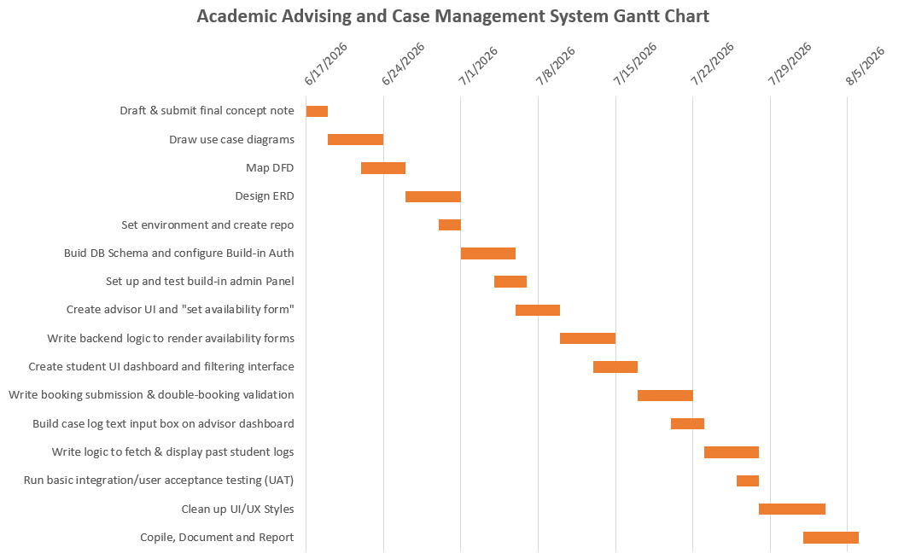

References
Amiri, S. M. H. (2026). Learning Analytics for Predicting Student Performance in Online Learning Environments. Preprints. https://doi.org/10.20944/preprints202603.1312.v1
James, W., Oates, G., & Schonfeldt, N. (2024). Improving retention while enhancing student engagement and learning outcomes using gamified mobile technology. Accounting Education, 1–21. https://doi.org/10.1080/09639284.2024.2326009
Peddi, S. (2024). Ethical Guidelines for the thoughtful Implementation of AI and Information Automation in Higher Education. Dialnet, 4(1), 88–97.

